University of Central Missouri

Department of Computer Science & Cybersecurity

CS5720 Neural network and Deep learning

Fall 2026

Home Assignment 1.

Student name: Ruyi Gai

Submission Requirements:
- Once finished your assignment push your source code to your repo (GitHub) and explain the work through the ReadMe file properly. Make sure you add your student info in the ReadMe file.
- Submit your GitHub link and video on the Bright Space.
- Comment your code appropriately IMPORTANT.
- Make a simple video about 2 to 3 minutes which includes demonstration of your home assignment and explanation of code snippets.
- Any submission after provided deadline is considered as a late submission.

Part I. Short answer
Question 1
a. Explain the main difference between traditional programming and machine learning.
Traditional programming uses predefined rules and data to produce answers.
Machine learning learns patterns or rules from data and uses them to make predictions or decisions.
b. Describe the relationship among Artificial Intelligence, Machine Learning, and Deep Learning.

AI is a technique which enables machines to mimic human behavior. ML is subset of AI technique which uses statistical methods to enable machines to improve with experience. DL is subset of ML which makes the computation of multi-layer neural network feasible.
Relationship: DL ∈ ML ∈ AI
c. Give two reasons why deep learning has become more successful in recent years.
Deep learning can handle high-dimensional data and automatically extract useful features.
The availability of large amounts of training data and powerful GPU computing has made deep learning more effective.

Question 2
a. Describe the roles of the input layer, hidden layer, and output layer in a neural network.
Input layer: Receives raw data.
Hidden layer: Perform transformations to extract meaningful patterns with one or multiple layers. Detecting edges, shapes, or textures in images.
Output layer: Provides the final prediction or classification.
b. What are weights and biases, and how are they used by an artificial neuron?
Weights determine the importance of each input, while bias adjusts the neuron's output or activation threshold. The neuron multiplies each input by its weight, adds the bias, and then applies an activation function to produce the output.
c. Why is an activation function needed in a neural network?
An activation function determines whether a neuron should be activated or not. It also introduces non-linearity, allowing the neural network to learn complex patterns.
Question 3
a. What is a perceptron, and how does it produce a binary output?
A perceptron is a simple neural unit that uses a linear decision boundary to classify inputs. It calculates a weighted sum of the inputs, adds a bias, and produces a binary output (0 or 1) based on a threshold.
b. Why can a single perceptron solve the AND and OR problems?
AND and OR problems are linearly separable, and a perceptron is a linear classifier. Therefore, a single perceptron can use a linear decision boundary to separate the outputs into 0 and 1.
c. Explain why a single perceptron cannot solve XOR and how a multilayer neural network solves this limitation.
XOR is not linearly separable, and a perceptron is a linear classifier, so a single perceptron cannot solve XOR. A multilayer neural network solves this limitation by using multiple layers and nonlinear activation functions to learn more complex patterns.
Question 4
a. Compare Sigmoid, Tanh, and ReLU in terms of their output ranges or behavior.
Sigmoid: The output is in the range (0, 1). It is useful for probabilistic outputs, especially for binary classification.
Tanh: The output is in the range (-1, 1). It is similar to the sigmoid function, but it is symmetric around the origin and is zero-centered.
ReLU: The output is in the range [0, +∞), defined as max(0, x). It helps reduce the vanishing-gradient problem and is fast to compute. It does not activate all neurons at the same time because negative inputs produce an output of zero.
b. What is the vanishing-gradient problem, and why does ReLU help reduce this problem?
The vanishing-gradient problem occurs when gradients become very small during backpropagation, making the weights update very slowly and causing the network to learn slowly. ReLU helps reduce this problem because its gradient is 1 for positive inputs, which allows gradients to pass through the network more effectively.
c. Briefly describe the following neural-network training cycle: forward propagation → error/loss calculation → backpropagation → weight update.
Forward propagation: The input data passes through the network to produce a prediction.
Error/Loss calculation: The loss function compares the prediction with the actual target to measure the error.
Backpropagation: The error is propagated backward through the network to calculate the gradients of the weights and biases.
Weight update: The weights and biases are updated using the gradients to reduce the loss and improve the model.

Part II. Programming
- Tensor Manipulations & Reshaping

Task: Tensor Reshaping & Operations
- Create a random tensor of shape (4, 6).
- Find its rank and shape using TensorFlow functions.
- Reshape it into (2, 3, 4) and transpose it to (3, 2, 4).
- Broadcast a smaller tensor (1, 4) to match the larger tensor and add them.
- Explain how broadcasting works in TensorFlow.
Expected Output:
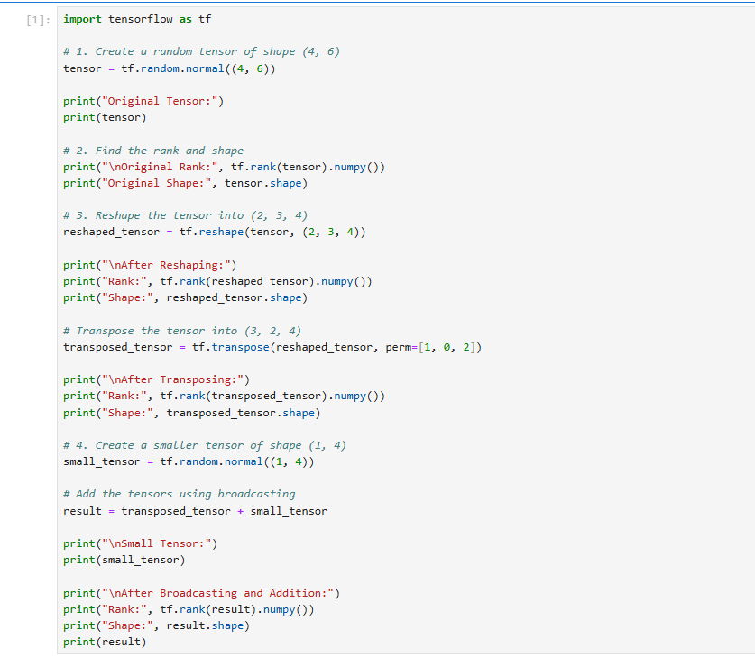
- Print rank and shape of the tensor before and after reshaping/transposing.
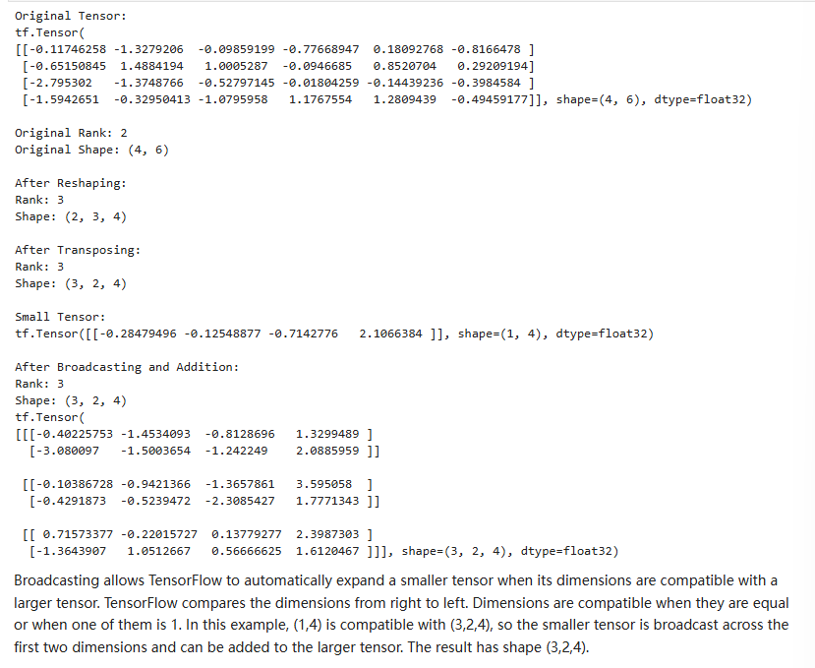
- Loss Functions & Hyperparameter Tuning

Task: Implement and Compare Loss Functions
- Define true values (y_true) and model predictions (y_pred).
- Compute Mean Squared Error (MSE) and Categorical Cross-Entropy (CCE) losses.
- Modify predictions slightly and check how loss values change.
- Plot loss function values using Matplotlib.
Expected Output:
- Loss values printed for different predictions.
- Bar chart comparing MSE and Cross-Entropy Loss.

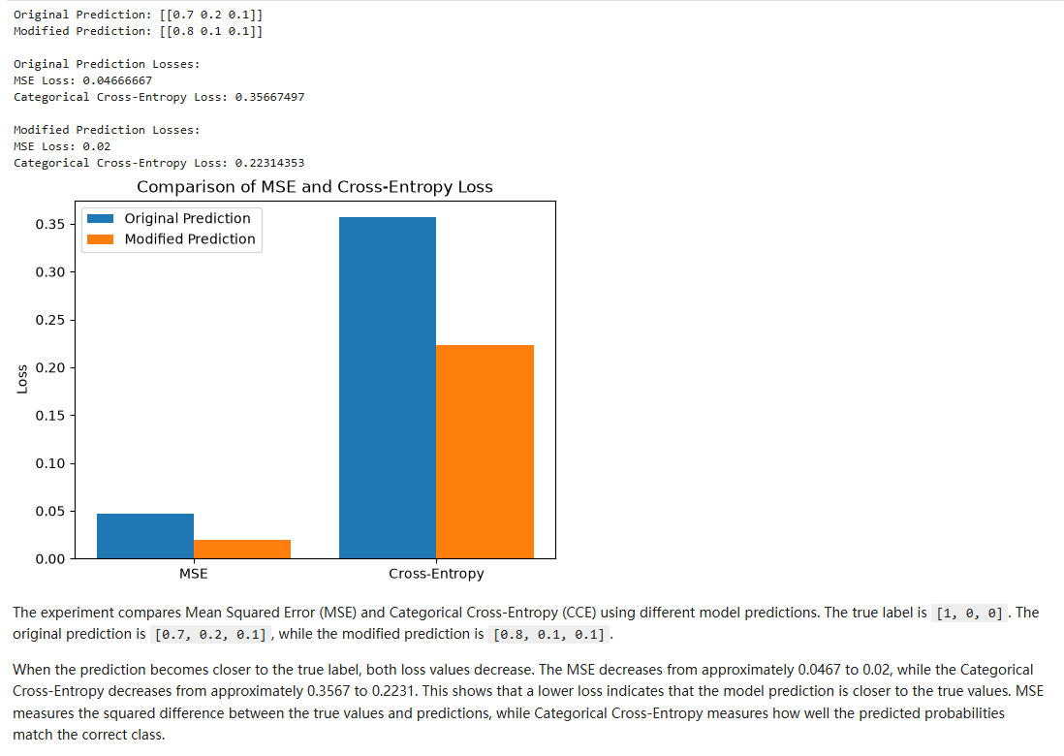
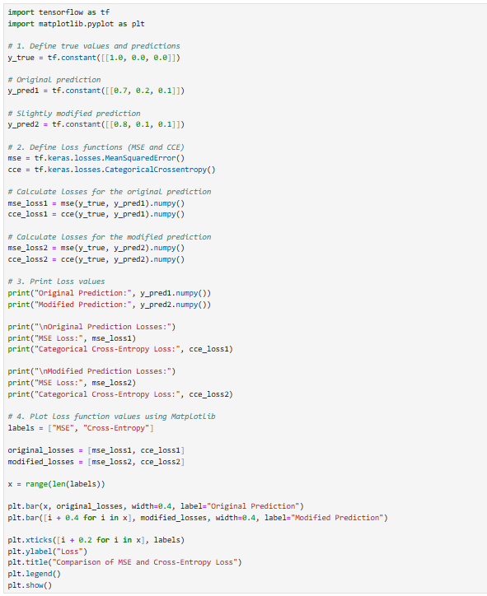
- Train a Model with Different Optimizers

Task: Train MNIST Model with Adam & SGD
- Load the MNIST dataset.
- Train two models: One with Adam and another with SGD.
- Compare training and validation accuracy trends.
Expected Output:
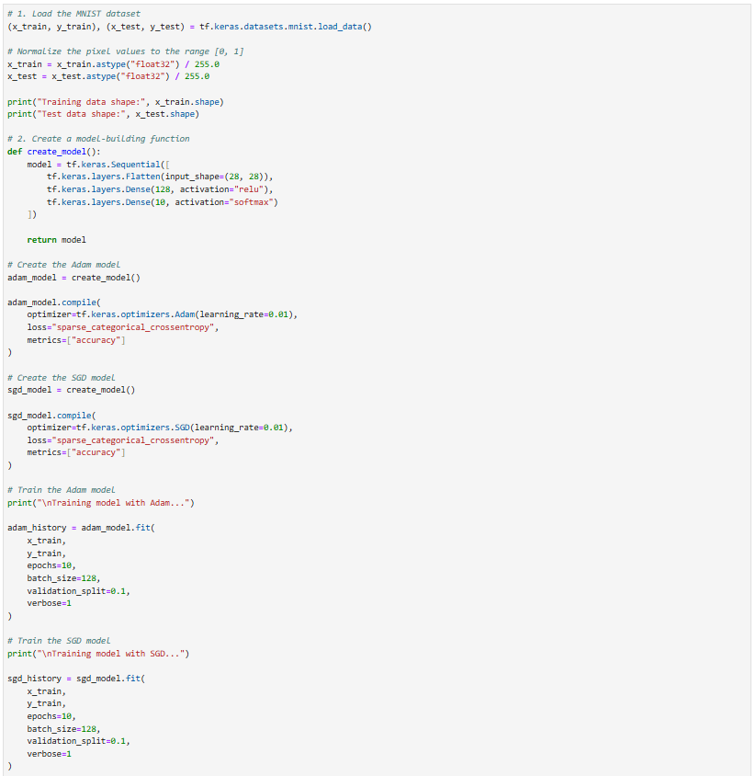
- Accuracy plots comparing Adam vs. SGD performance.
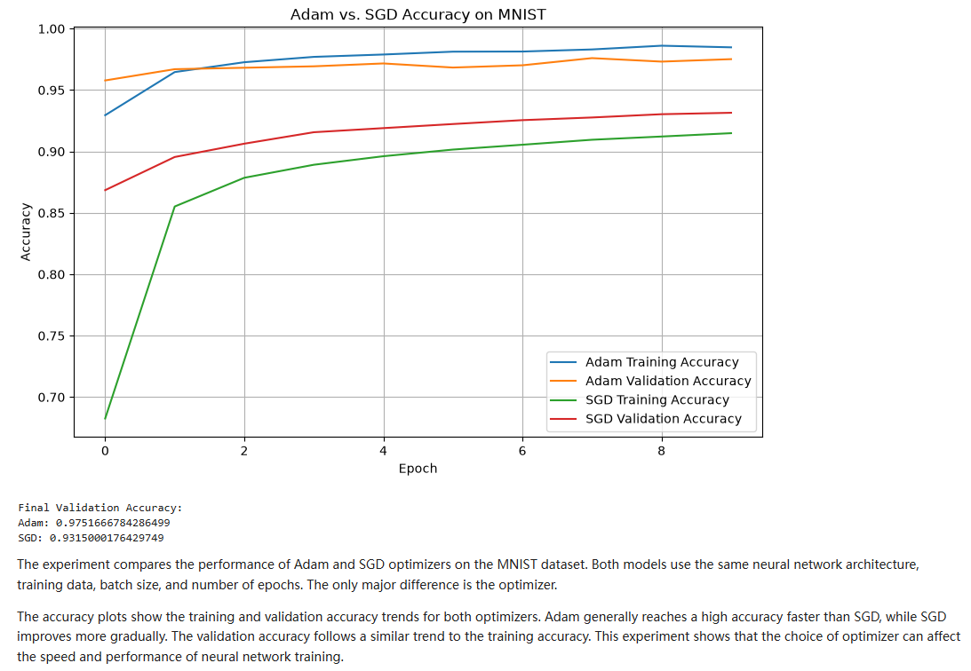
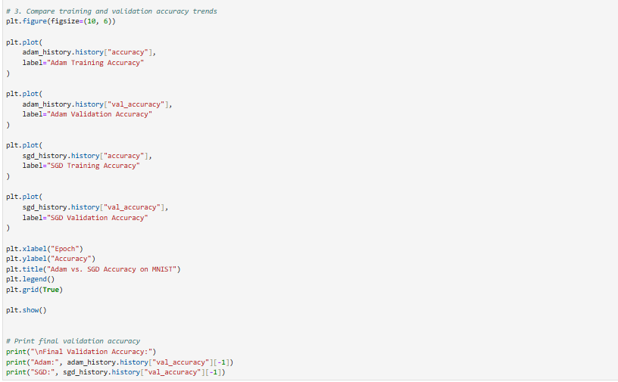
- Train a Neural Network and Log to TensorBoard

Task Description
- Load the MNIST dataset and preprocess it.
- Train a simple neural network model and enable TensorBoard logging.
- Launch TensorBoard and analyze loss and accuracy trends.
Expected Outcome:
- The model should train for 5 epochs and store logs in the "logs/fit/" directory.
- You should be able to visualize training vs. validation accuracy and loss in TensorBoard.
4.1 Questions to Answer:
- What patterns do you observe in the training and validation accuracy curves?
- How can you use TensorBoard to detect overfitting?
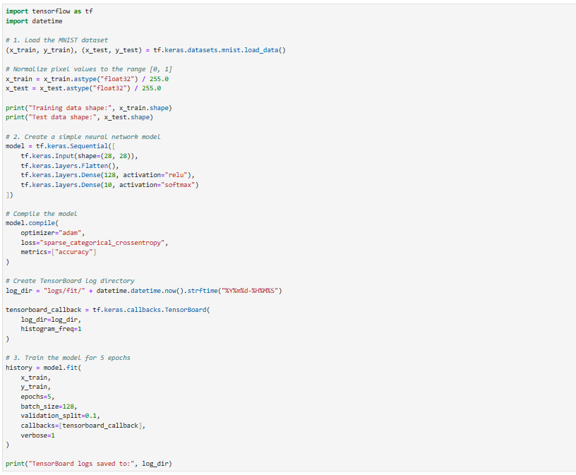
- What happens when you increase the number of epochs?
